

**Introduction Server Technologies and Management Services**

Presented by: Bùi Hương Linh

Class: GCH1006 Student ID: GBH200662 Tutor: Dzung Lai

Table of Content

Identify the purpose and types of DNS, including explanations on how domain names are organised and managed.

1

1. Explain the purpose of

Communication protocols Server hardware Operating systems

Web server software

Explain the relationship between technologies above with regards to designing, publishing**1**and accessing a website.

1. Discuss the capabilities and relationships between front-end and back-end website technologies. Explain how these relate to presentation and application layers

Areview of different website technologies supported with the tools and sofware used to develop websites

4

Frond-end technologies Back-end technologies Databases

IDEs CMS

Website builders



* 1. Indentify the purpose and types of DNS, including explanations on how domain names are organized and managed.

So, in order to better understand how a website works, we must first understand the website components, including the tools/means used to make it work.

### Introduction to WWW & History of the World Wide Web

What is Word Wide Web?

The World Wide Web, also known as a Web, is a collection of websites or web pages stored in web servers and linked to local computers via the internet. Web pages formatted in HTML and linked by links called "hypertext" or hyperlinks and accessed via HTTP are the building blocks of the Web.

## Introduction to WWW & History of the World Wide Web

History of Web

Tim Berners-Lee, a British scientist, created the World Wide Web (WWW) while working at CERN in 1989. The Web was created to meet the demand for automated information sharing among scientists in universities and institutes around the world.

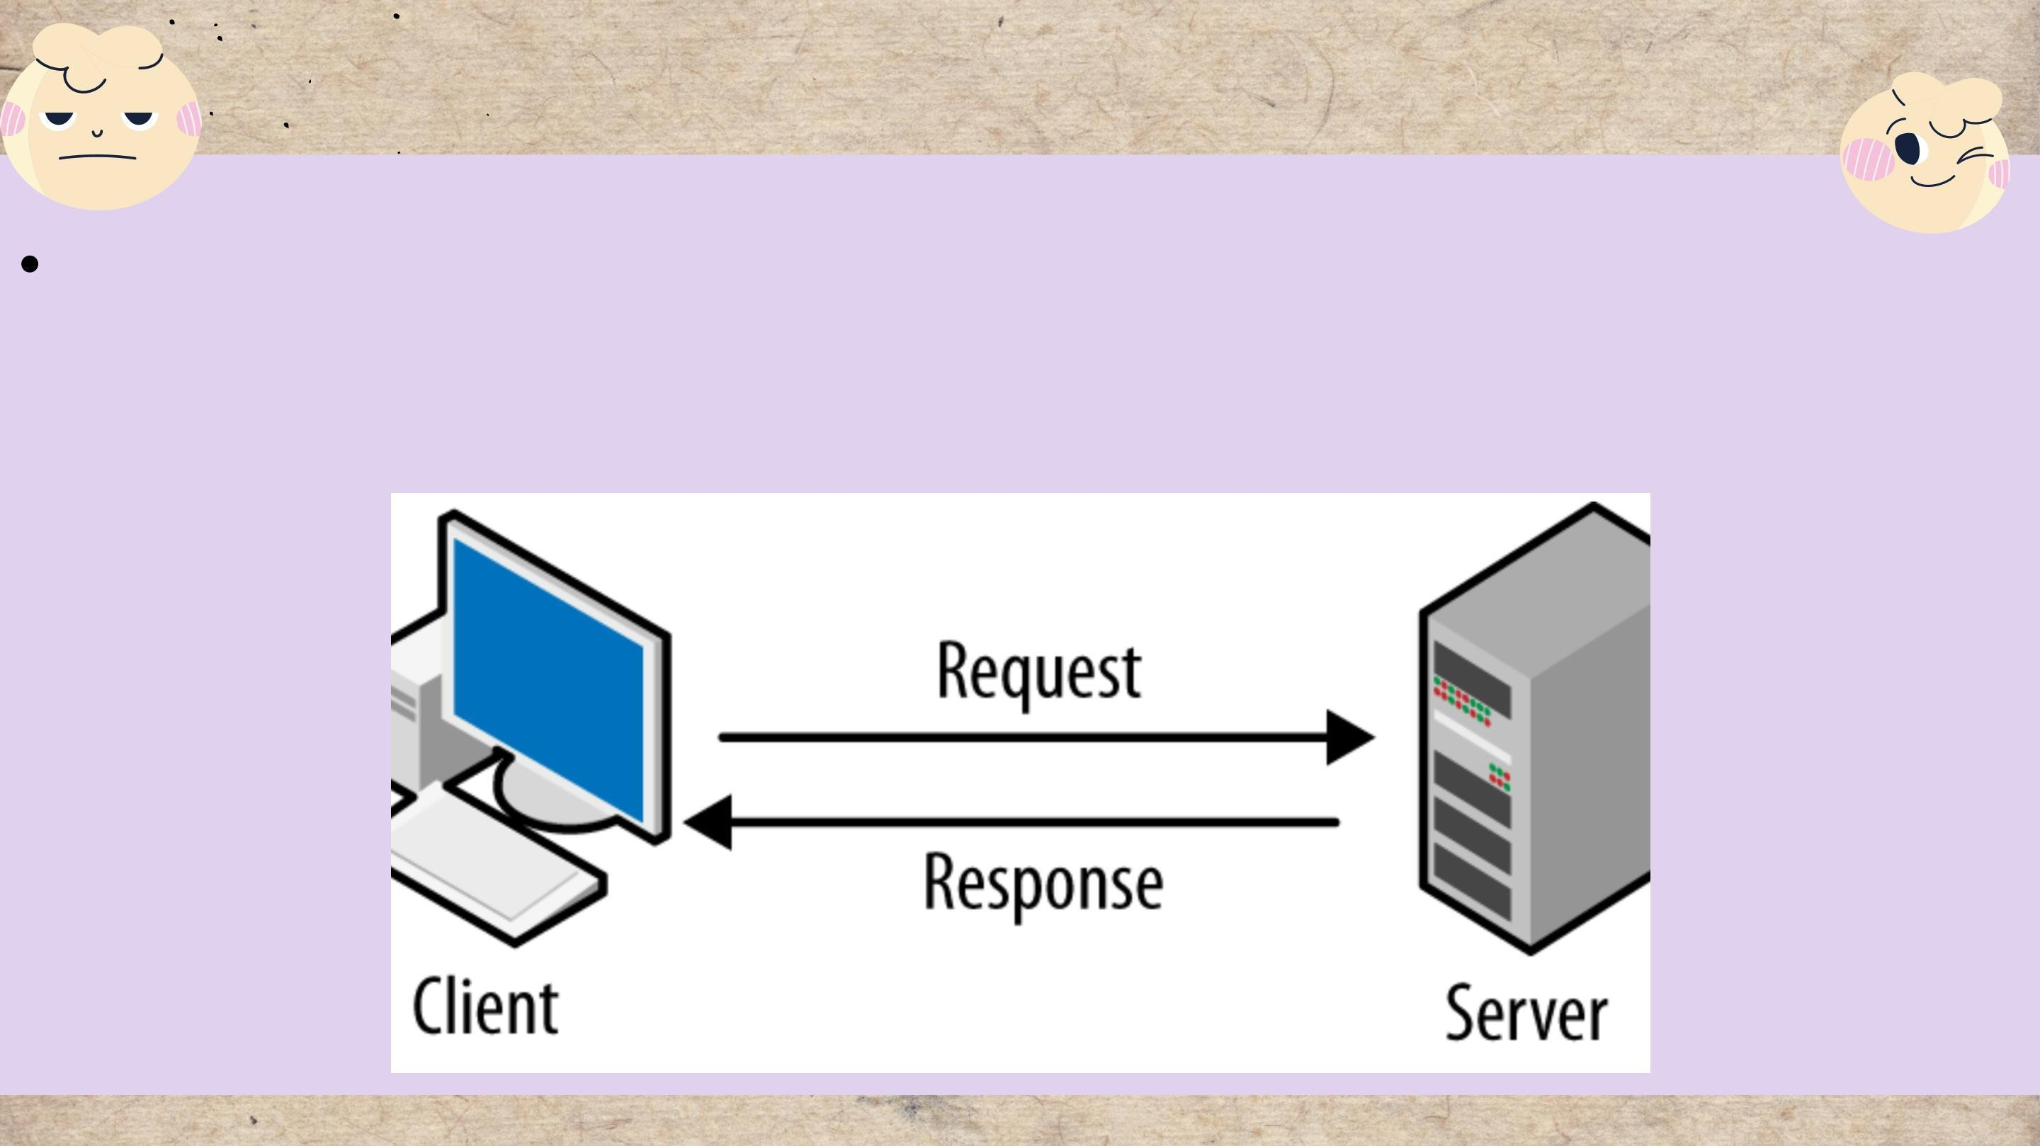How the Web works

Clients and server

Clients are the internet-connected devices of the average web user (for example, your computer connected to your Wi-Fi or your phone connected to your mobile network)

## How the Web works

Web server

A place to store source code and website content.

The web server is identified by its IP address.

Websites often use a small portion of the web server's resources.

# Domain name system (DNS)

The Domain Name System (DNS) is a collection of databases that convert hostnames to IP addresses. DNS is known as the internet's phone book because it convertNavigating the internet would be difficult without DNS (especially search engines like Google), because we'd have to enter the IP address of each website we wanted to visit.

# Purpose of DNS

DNS's primary function is to provide mapping between symbolic names and IP addresses in a global hierarchical and hierarchical database.

Converts human readable domain name intro Internet

Protocol (IP) addresses and vice versa.

Protocol (IP) addresses and vice versa A list of names that correspond to

numbers.

# Types of DNS

DNS queries

DNS query is also known as a DNS request. So, it is a request for information that is sent from the user’s computer to ask for the IP address to a DNS server. This means the DNS client is querying the DNS server to get the IP address, related to that domain.

Record

A DNS record was created by the DNS server to provide important information about the domain or hostname as well as its current IP address.

DNS Servers

DNS servers are responsible for converting domain names into IP addresses. It takes human requests and converts them into machine IP addresses, making it easier to reach the origin server DNS

# Explain the purpose of

Communication protocols Server hardware Operating systems

Web server software

Explain the relationship between technologies above with regards to designing, publishing and accessing a website.

# Communication protocols

What does Communication protocols?

Protocols for communication are formal descriptions of digital message formats and rules. They must exchange messages within or between computing systems.

Protocols for communication can cover authentication, error detection and correction, and signaling. They are also capable of describing the syntax, semantics, and synchronization of analog and digital communications.

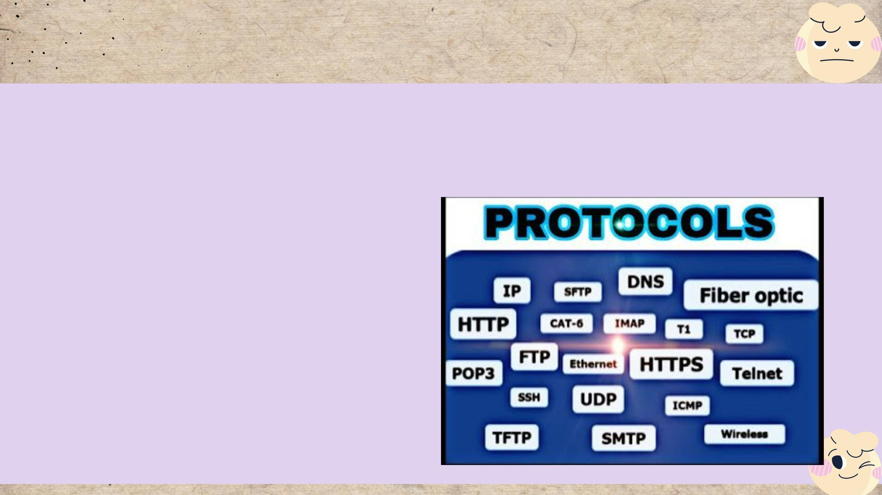Communication protocols

Types of protocols

Before successful transmission can occur, networked communications devices must agree on many physical aspects of the data to be exchanged. "Protocols" are rules that define data transmissions.

A protocol can define a wide range of transmission properties.

Protocols may address the following properties, for example:

* Packet size.
* Transmission speed.
* Error correction types.
* Routing.
* Address formatting.

# Communication protocols

Transmission Control Protocols (TCP)

TCP is an abbreviation for Transmission Control Protocol, a communications protocol that allows application programs and computing devices to exchange messages across a network.

TCP is a popular communication protocol that is used for network communication. It divides any message into a series of packets that are sent from source to destination, where they are reassembled.

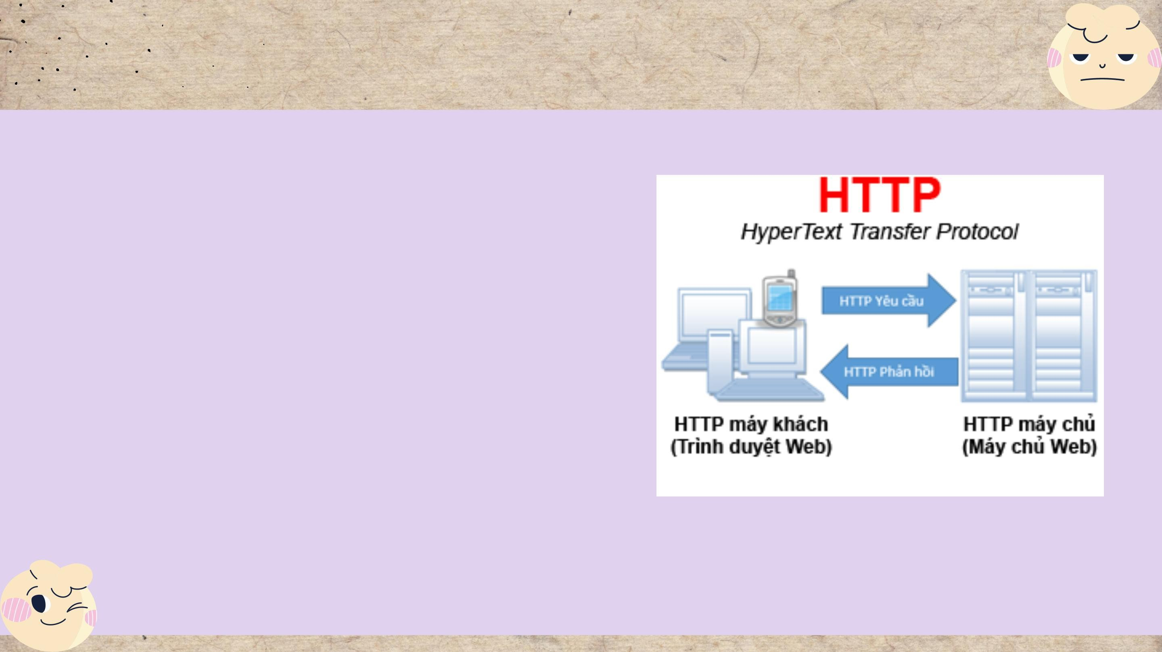Communication protocols

Hypertext Transfer protocols

(HTTP) is an application-layer protocol that is used to transmit hypermedia documents such as HTML. It was created to facilitate communication between web browsers and web servers, but it can also be used for other purposes. HTTP is a stateless protocol, which means that the server does not store any data (state) between requests.

# Server hardware

Server Hardware is defined as computer hardware that operates in a local area network and runs administrative software that controls access to all or part of the network and its resources and makes such resources available to computers acting as network workstations.

* + A computer with a large data memory
  + Organize, retrieve, and transmit computer files

and data.

* + Complete tasks to keep the workflow running

smoothly and productivity high.

# Operating systems

An operating system is simply a type of software that serves as a bridge between computer hardware and the end user. A computer requires an operating system in order to function.

An operating system's functions

An operating system provides various types of services to an application.

Benefits of an Operating System

There are numerous benefits to using an operating system. The operating system also provides easy-to-use resources to the user, acting as an intermediary between the hardware and software systems.

# Web Server Sofware

Server software is software that is intended to be used, operated, and managed on a computer server.

Alternatively, a server computer may be used to make files and programs available to other computers.

* + - Prevent SQL injections, XSS, and CSRF

attacks.

* + - With proper documentation and examples,

the configuration is simple to learn.

* + - A lightweight server that is ideal for older hardware and embedded systems • The best Unix web server with secure and advanced features.

# Web server

XAMPP

XAMPP is a simple Apache distribution that includes MySQL, PHP, and Perl. XAMPP is extremely simple to install and use – simply download, extract, and begin.

#### Discuss the capabilities and relationships between front-end

and back-end website technologies.

Dynamic Web Server

It is also a static web server that has been enhanced with the help of an application server or databases. When a client sends a request, the application server modifies or updates the hosted file before delivering it to the client via HTTP server.

Advantages

* Much more functionality
* Easy to update
* Always a fresh site the brings in new visitors or/and prospective

customers

* A system that provides for unique collaboration of the admin.,

staff and the visitors/users

Disadvantages

* + More expensive
  + Require time for development
  + Higher hosting costs

#### 3. Discuss the capabilities and relationships between front-end and back-end website technologies.

Static Web Server

It is built on the foundation of a physical server (hardware) and an HTTP server (software). When a client uses his browser to request a specific file, the static web server sends the hosted files in their entirety.

Advantages

* Are relatively easy to develop
* Are less expensive to develop
* Are also relatively inexpensive to host.

Disadvantages

* A good web-development expertise is required for updating static web-pages
* The site may not be very useful for visitors and users
* The site may suffer from content stagnation.

#### 3. Discuss the capabilities and relationships between front-end and back-end website technologies.

Front-end

Front-end development is an important aspect of web development that you should be familiar with. Front-end A developer is someone who creates interfaces based on design patterns.

* Proficient in programming languages such as HTML, CSS, and Javascript.
* Web design that is mobile-friendly.
* SEM (Search Engine Marketing) (SEO).
* AJAX and asynchronous request handling
* Issues with cross-browser compatibility and workarounds
* Testing from start to finish with a headless browser.
* A one-page application.

1. Discuss the capabilities and relationships between front-end and back-end website technologies.

Back-end

In contrast to Front-end, the work of a Back-end Developer is usually not visible to the outside world because they frequently manipulate the server and data.

* + Programming languages such as Node.js, PHP,

Python, Ruby, or Perl.

* + Language-specific Automated Testing Frameworks
  + Information transformation.
  + Access to Application Data
  + Concerns about security, authentication, and

authorization.

#### Relationships between front-end & back-end website technologies

Front-End and Back-End refer to the separation of concerns between the presentation layer, application layer, and database layer, as well as the application layer in front-end and two layers in back-end, namely application and database layer.

Three different layers of front-end and back end include:

* Presentation Layer
* Application layer
* Database Layer

#### A review of different website technologies supported with the tools & sofware used to develop website

Frond-end technologies Back-end technologies Databases

IDEs CMS

Website builders

# Front-end technologies

To be known as a front-end developer, you must first master some fundamental skills. Some of these require you to be an expert. Then there are the desirable abilities.

Front-end languages: HTML

CSS

Java scrip J query ReactJS

# Back-end technologies

Back-end technologies, such as languages, must be dealt with by programmers or back- end developers in order to handle the back end of given applications.

Back-end languages: Java

PHP

Python SQL ASP.NET

# CMS technologies

When you hear the word CMS, you immediately think of content management systems, don't you?

And now I'll introduce you to the

three most popular content management systems:

* CMS WordPress
* CMS Joomla
* CMS Magento

# Website Builders Technologies

Some website builders :

* + Wix
  + Squarespace
  + Weebly
  + Duda

••••

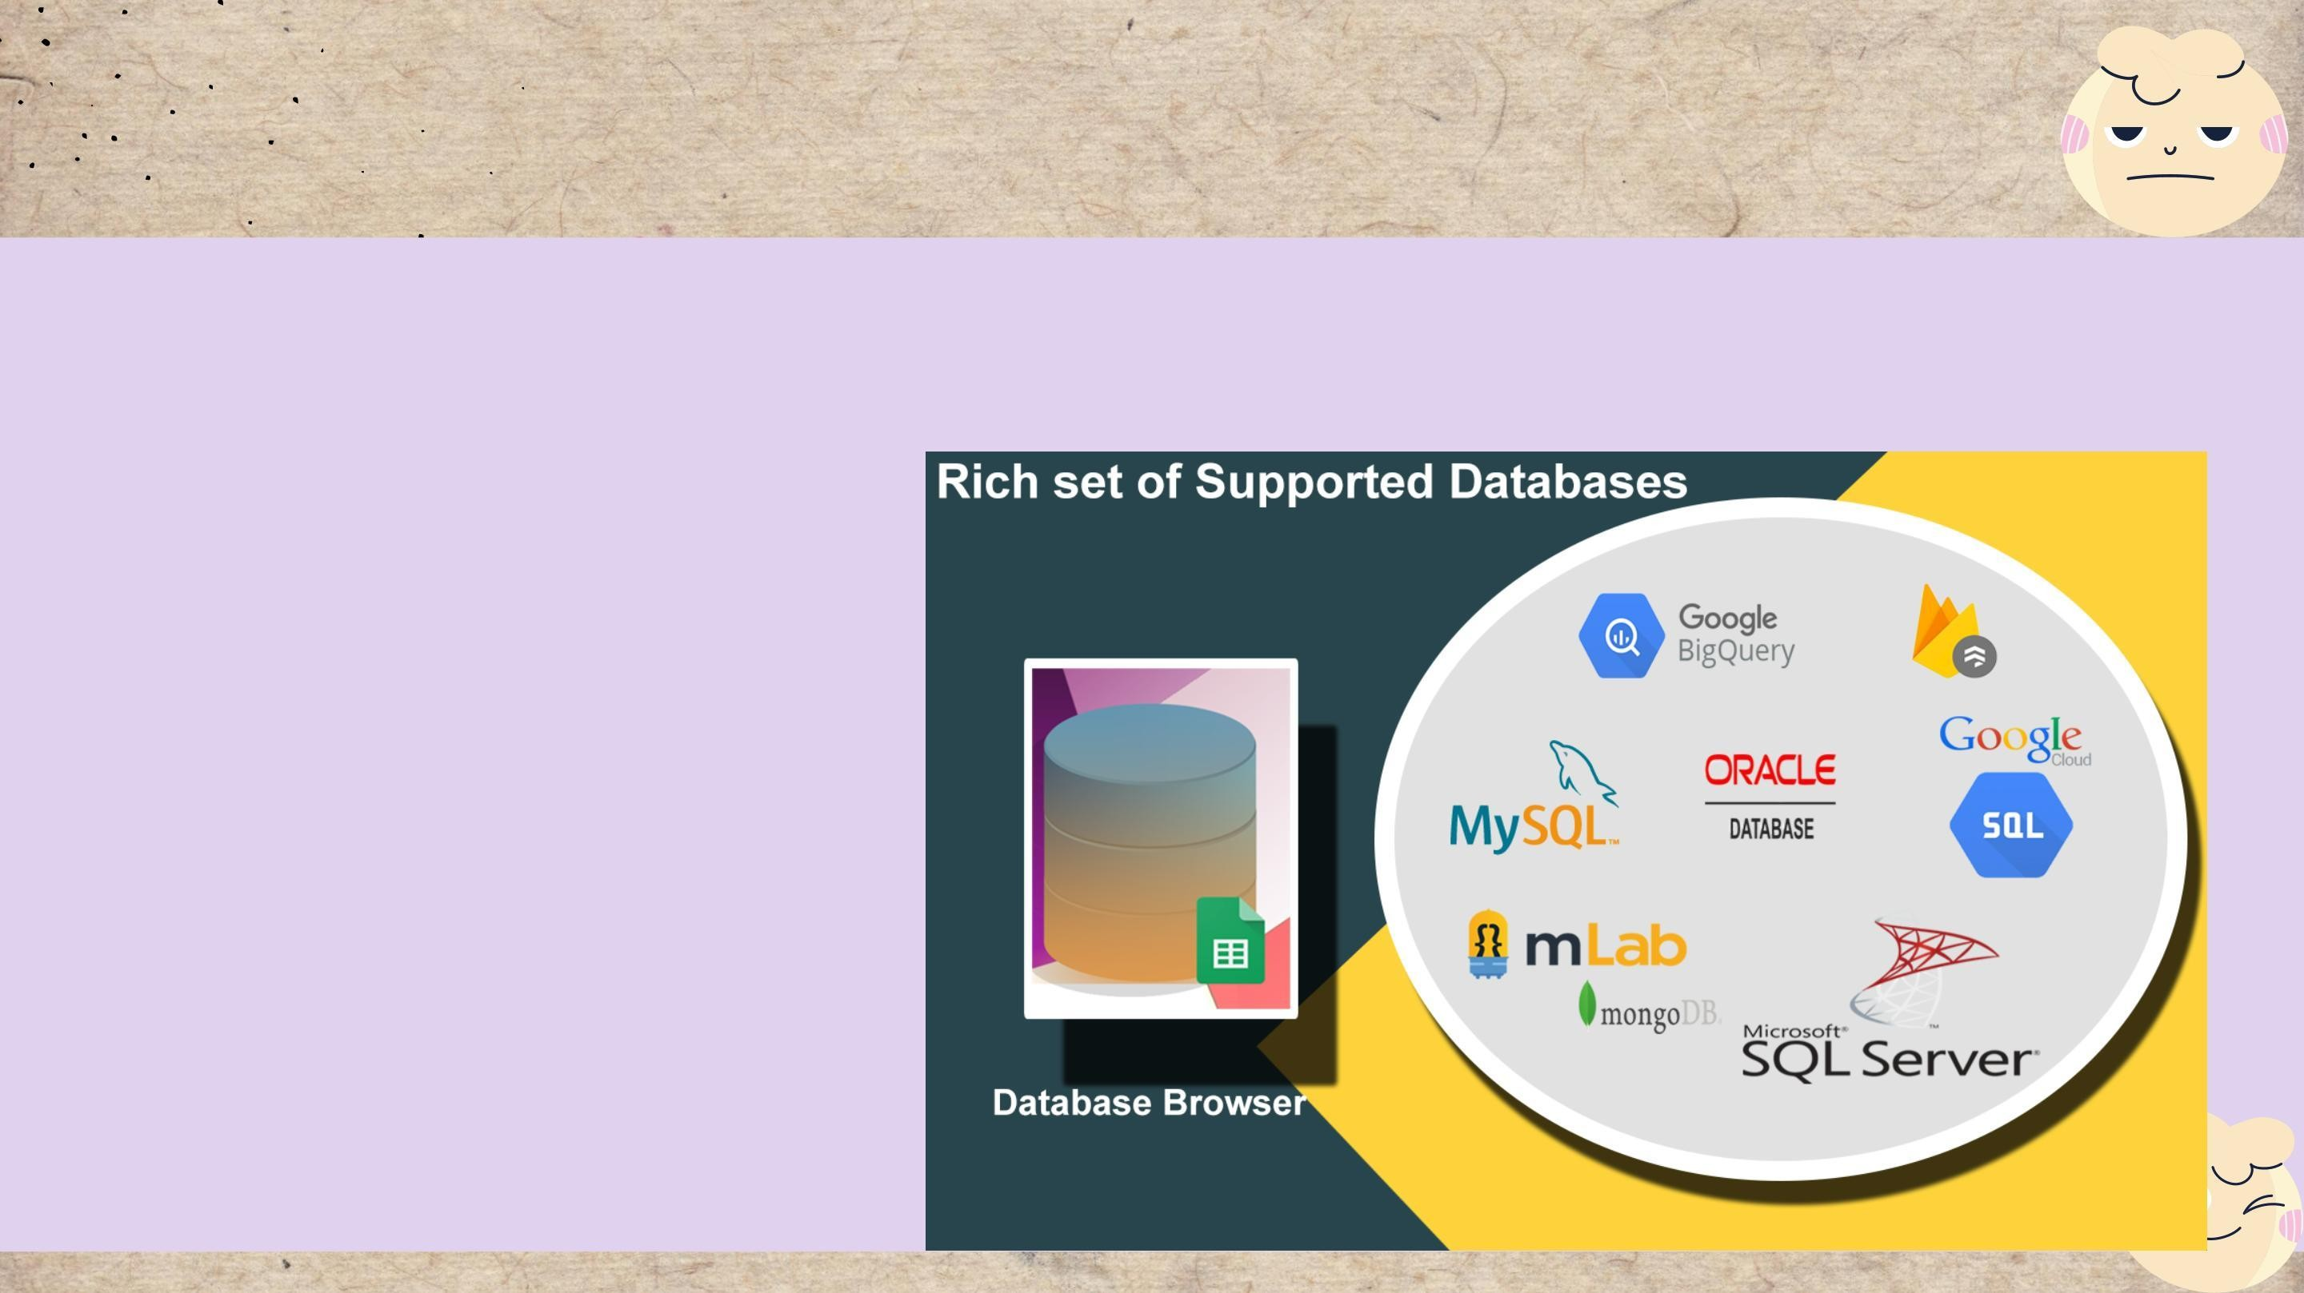Databases

Some Databases technologies use:

* + Microsoft SQL Server
  + PostgreSQL
  + MySQL

# IDEs technologies

#### Some IDE technologies use:

* + Visual Studio Code

#### IntelliJ IDEA

* + Sublime Text

#### Xcode

* + WebStorm

References

Bill, G., 2021. 26+ Top Web Server Software Free for Windows, Linux. [Online] Available at: https://freshdesignweb.com/web-server-software-free/ Cloudflare, 2022. DNS server types. [Online]

Available at: https:/[/www.cloudflare.com/learning/dns/dns](http://www.cloudflare.com/learning/dns/dns-server-)-[server-](http://www.cloudflare.com/learning/dns/dns-server-)

types/#:~:text=What%20are%20the%20different%20types,TLD%20nameservers%2C%20and%20authoritative%20nameserve

Dealna, 2022. Three Types of Server Hardware. [Online]

Available at: https://dealna.com/en/Article/Post/1391/Three-Types-of-Server-Hardware Developer, 2022. An overview of HTTP. [Online]

Available at: https://developer.mozilla.org/en-US/docs/Web/HTTP/Overview Developer, 2022. How the Web works. [Online]

Available at: https://developer.mozilla.org/en-US/docs/Learn/Getting_started_with_the_web/How_the_Web_works#clients_and_servers

Fortinet, 2022. What is a Transmission Control Protocol TCP/IP Model?. [Online] Available at: https:/[/www.fortinet.com/resources/cyberglossary/tcp](http://www.fortinet.com/resources/cyberglossary/tcp-ip)-[ip](http://www.fortinet.com/resources/cyberglossary/tcp-ip) Javatpoint, 2021. What is World Wide Web?. [Online]

Available at: https:/[/www.javatpoint.com/what](http://www.javatpoint.com/what-is-world-wide-web)-[is-world-wide-web](http://www.javatpoint.com/what-is-world-wide-web)

Max, D., 2020. Choose Best Web Server from a Number of Open Source Web Servers. [Online]

Available at: https:/[/www.temok.com/blog/choose](http://www.temok.com/blog/choose-best-web-server-from-a-number-of-open-source-web-servers/)-[best-web-server-from-a-number-of-open-source-web-servers/](http://www.temok.com/blog/choose-best-web-server-from-a-number-of-open-source-web-servers/)

Networkstraining, 2022. DNS Port Number – What is Domain Name System – How DNS Works. [Online]

Available at: https:/[/www.networkstraining.com/what](http://www.networkstraining.com/what-is-dns/)-[is-dns/](http://www.networkstraining.com/what-is-dns/)

Ns1, 2022. DNS: Types of DNS Records, DNS Servers and DNS Query Types. [Online]

Available at: https://ns1.com/resources/dns-types-records-servers-and-queries

springwk_wp, 2015. The Various Differences Between The Static And The Dynamic Web Pages And Websites. [Online] Available at: https:/[/www.springworks.biz/2015/11/24/static](http://www.springworks.biz/2015/11/24/static-and-dynamic-website/)-[and-dynamic-website/](http://www.springworks.biz/2015/11/24/static-and-dynamic-website/)

Trego, M., 2016. Front-end & Back-end Web Development: Your Ultimate Guide. [Online]

Available at: https://blog.stoneriverelearning.com/front-vs-back-end-web-development-your-ultimate-guide/

